ART285: Interactive Audio Design
Lesson 4a: Song Structure

Looking Ahead at the Assignment
Assignment 4 is divided into two parts. First you will choose three short songs (less than five minutes) and make screen shots of the waveforms. Then choose one of the songs which show a clear song structure. Create a new document that is 960px wide by 540 pixels tall and bring that waveform into Photoshop, placing it at the top of the page and divide it into its structural parts. For more information about the topic and a demonstration of how to get started, please watch the following videos.
Video 1
https://youtu.be/N-rOTjZne4w
Video 2
https://youtu.be/xQQg7_W4dQU
Video 3
https://youtu.be/CWj3gxY1zoo

For part two, you will be making an interactive webpage based on the song that you chose. The user can play individual sections of the song while highlighting the waveform. The code will be provided and explained, so do not stress part 2, while you are working on part 1.
Here are some previous students' analysis of the parts of different songs.

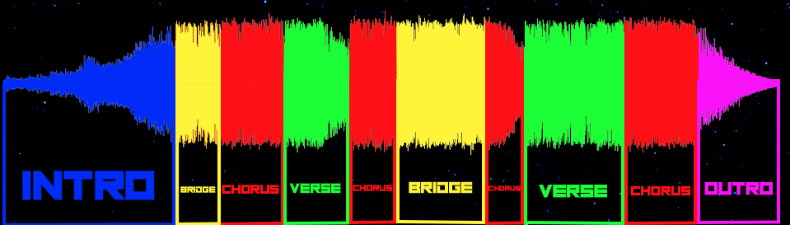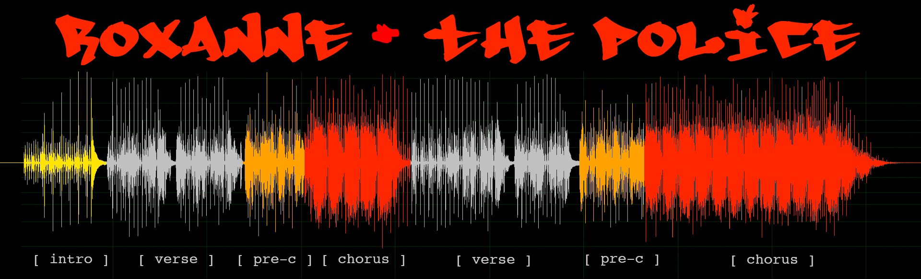

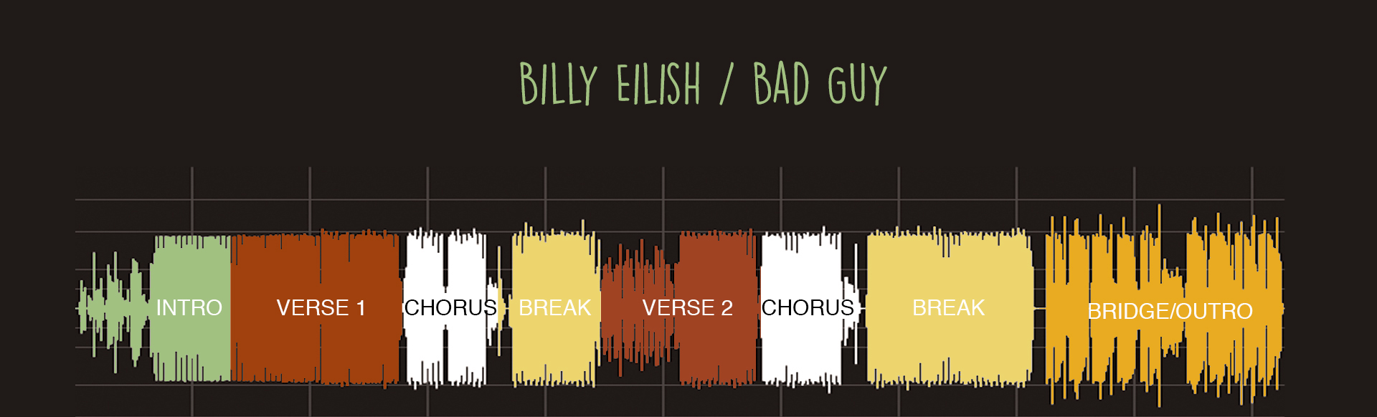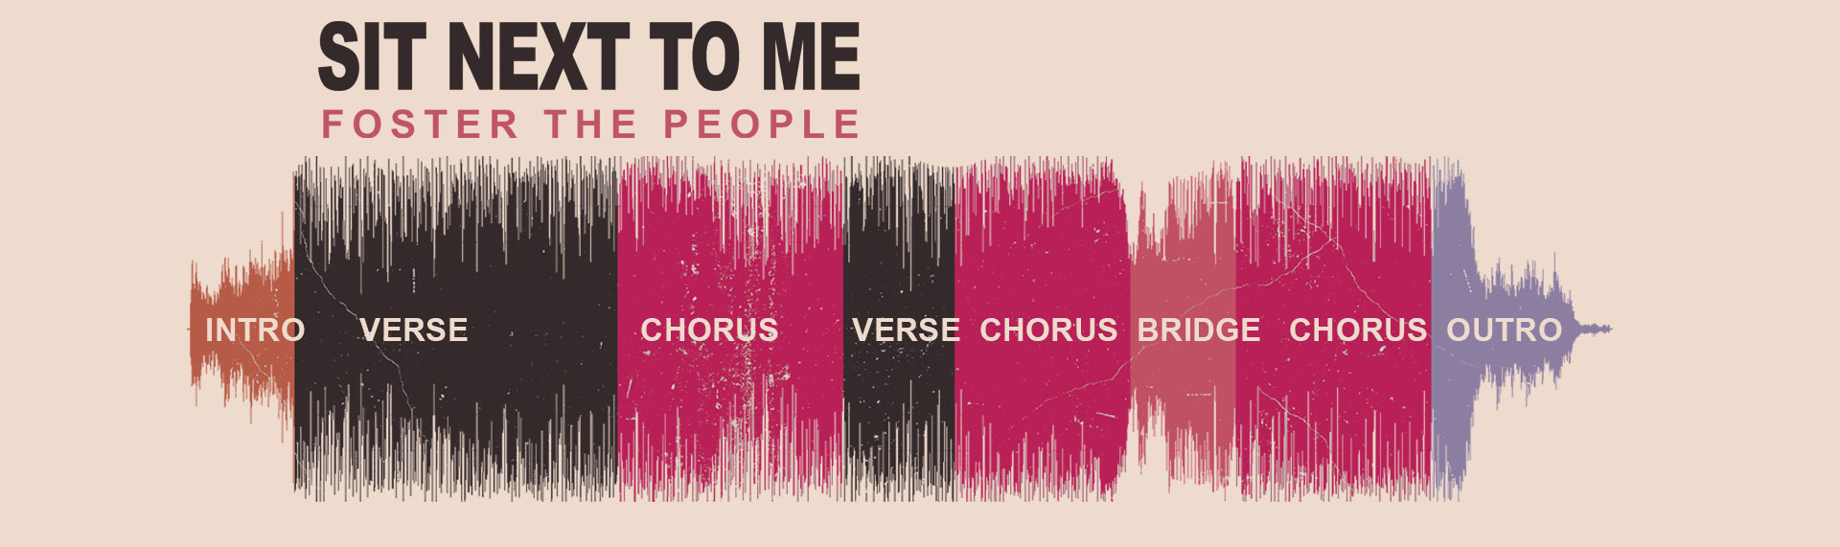

Analyzing Popular Music from the 20th Century to Present
The study of musical structure does more than prepare you for writing original songs. The repeating patterns, distinct sections, and fidelity to the story arc is universal across all forms of time-based media. Movies, series, books, short stories, videogames, and even jokes share structures that are similar, and learning about those structures makes your work in any medium or genre stronger. Let's review the structure of the story arc and look at how a variety of media use those elements.

I mentioned above that movies, music, video games, and jokes all share common structures. The story arc starts with exposition which describes the scene, introduces the characters, sets the tone, and begins the action. The opening scene of a movie, whether it is the words "A long time ago in a galaxy far, far away" or starting in the middle of the story (in medias res) like Pulp Fiction, sets up the character, setting, and mood. Some joke cycles do the same thing. The famous joke starters, "a priest, a rabbi, and a _____________ walk into a bar" or "Why did the chicken cross the road?" both act as exposition and set the place, characters, and often the mood. Music also starts with an intro that often sets the tempo (speed), beat patterns, and instrumentation. It is clear from the first few seconds of a song that you have not heard before what genre it is from.

The story arc continues to the rising action, which builds tension through struggle or conflict. In film and television genres, there are specific recurrent tropes (situations, character types, and dialog that appear over and over in stories, like the ‘chase scene’ or the ‘overbearing neighbor’). The main characters are challenged by an opposing force, like an evil stepmother, a nemesis, social injustice, peer pressures, violence and war, a conflicted conscience, being stuck in the wrong time period, being stuck with the wrong partner, racing against the clock, etc. In music the rising tension can be created in the lyric (the words sung to the music) or through types of instrument arrangement, tempo changes, or a break (complete change to the song for a short time, only to return to the main chorus). By creating interactions between different instruments, a bass guitar and a lead guitar, a low synth hit and record scratch, etc. tension can be created and built towards the climax. A break can introduce a new trajectory for the song, which is jarring against the pattern that was established in the intro, verse, and chorus.

In storytelling, the action turns at the climax, where the rising tension leads to something being revealed, overcome, defeated, or accepted. In a joke, the climax is the punchline. In music, the climax can be at the first chorus following a break or a bridge, a unique verse, or just an increase in intensity and volume. Here again, there are many repeated tropes, like a long pause at the climax of country music ballads, an over-the-top guitar solo in hair-band anthems, or an unexpected, featured artist duet in pop love songs.

While there are many different song structures, from classical orchestras to modern noise bands, popular music of the twentieth century established a standard structure that is used in rock, pop, rap, country, rhythm and blues, and even punk and alternative music. The basic pattern of verse, chorus, verse, chorus, bridge, chorus, chorus is the most common. Another, more complex pattern is intro, verse, chorus, verse, chorus, bridge, verse, chorus, outro.

These distinct sections are the building blocks of song construction, just as scenes or acts are in a movie, series, or play.

Intro – The opening of the song, which establishes a tempo and a beat, introduces the instruments and voices, and sets a mood or tone. Sometimes it starts with a drum beat and instruments are added one by one, while other times it starts a cappella (a single singer).

Verse – The story in the song. Verses are like poems which retain similar rhythms and patterns across different lines of text.

Chorus – The main message of the song. A chorus, traditionally, means a group of voices and repeats a recurring theme. Choruses repeat either word for word or with only small variations, tying the verses together while breaking up the story and creating continuity across the song.

Bridge – A variation of a verse, which either plays without vocals or has a change in key signature or chord pattern. The bridge sets up the final chorus, which is the climax of the song.

Break – Sometimes called the breakdown. The break modifies the feel of the song for a short time, through changes in tempo, key signature, or instrumentation. The break creates tension, by interrupting the flow of the song, and relieves the tension when the normal pattern returns.

Outro – Sometimes called the coda, if the song repeats and fades. The outro wraps up the song through a variation of the chorus, a stripping down of the number of instruments, or a fade.

Lyric – The words of a song. While the music creates a mood or feeling, the words of a song create a specific message. Often times pop songs are not written by their performer and song lyricists sell their work to others.

Chord Progression – The sequence of chords (combination of individual notes) that make up the verse and chorus. There are about a dozen progressions that are used by many songs, for instance Journey's Don't Stop Believing, Lady Gaga's Paparazzi, The Cranberry's Zombie, and Green Day's When I Come Around, all share the same chord progression.

Melody – The main musical sequence or notes of a vocal line. The melody is the musical notes that play over the chord progression that lead us through the song. It is the notes that we sing, hum, or whistle when we summarize the song.

Hook – A melody that is simple, recognizable, and gets stuck in your head. In rock, the hook is usually a guitar line that is introduced in the intro and is repeated throughout. For instance, the bass line hook from the David Bowie and Queen's song Under Pressure was used by Vanilla Ice and is instantly recognizable.

Rhythm – The beat of the music, either through the use of drums, guitar, or even vocal beats. Rhythm is established by any sustained repeating sound. Rhythm is the backbone of a song and establishes the tempo and dynamics.

Tempo – The speed of the beat or rhythm. Tempo is how fast the song is played and is measured in Beats Per Minute (BPM).

BPM – The Beats Per Minute of a song. Usually measured from the frequency of the rhythms or drum beat, a fast song creates a different feel from a slow ballad. Songs with matching BPMs are often chosen by DJs who want to transition from one song to the other.

Arrangement – The instruments selected and overall structure of a song. A song can be recorded by two separate bands or groups and sound starkly different. Different artists can choose unique instrumentation, tempo, and choice of instrument to create a new version of the song.

